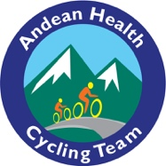
Email Template for Natchez Trace Riders
Dear Friends and Family,

This October I am participating in a [3-day/7-day] bike ride on the Natchez Trace Parkway to raise funds and awareness for Andean Health & Development, a healthcare non-profit in rural Ecuador founded by my friend, Dr. David Gaus. I am biking [179 miles/457 miles] for this cause with 23 other riders.

Andean Health is an organization I have been following and supporting for many years. They:
- provide high quality medical care to Ecuador’s most underserved people in a sustainable way
- employ 100% local, Ecuadorian staff
- train local physician residents to be the next generation of global health leaders
- conduct meaningful public health research

To donate, please visit www.andeanhealth.org/donate-to-ahd and select my team name, “[_____]” to make a gift to my campaign. Or join my team and ride with me from wherever you live!

More info about Andean Health’s good work is available at www.andeanhealth.org. Donations are tax-deductible. Thank you for your consideration!

Sincerely,

[Your Name]

